* We create button for the elastic block storage on the right-hand side of the window in elastic block section in volume page click on that. 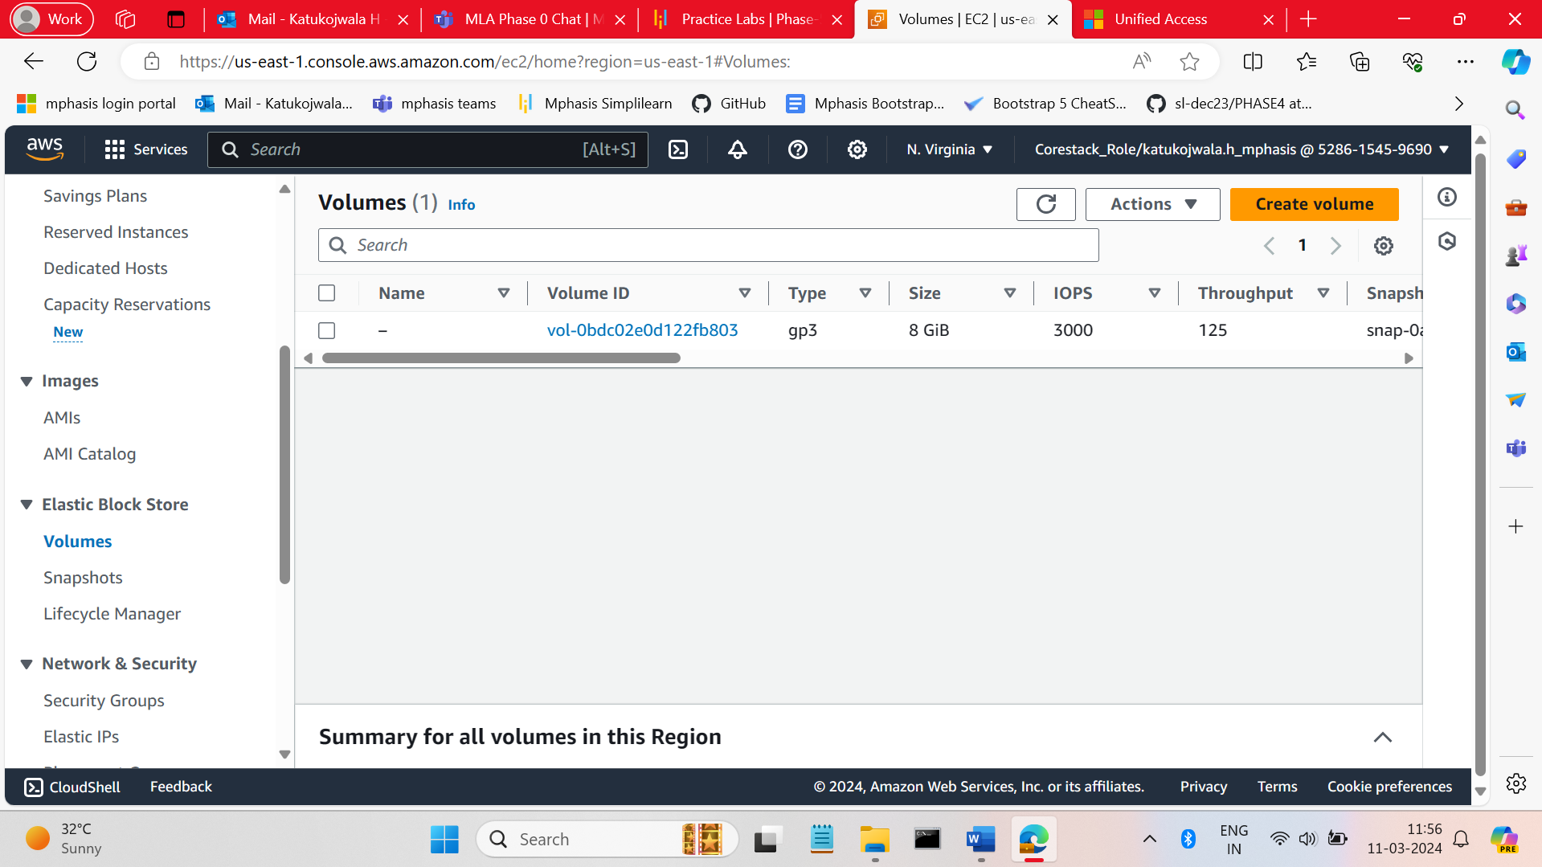
* Create Volume page will be opened in that enter the size of the volume, IOPS and availability zone name tag name has required. By clicking on the create button the volume will create. 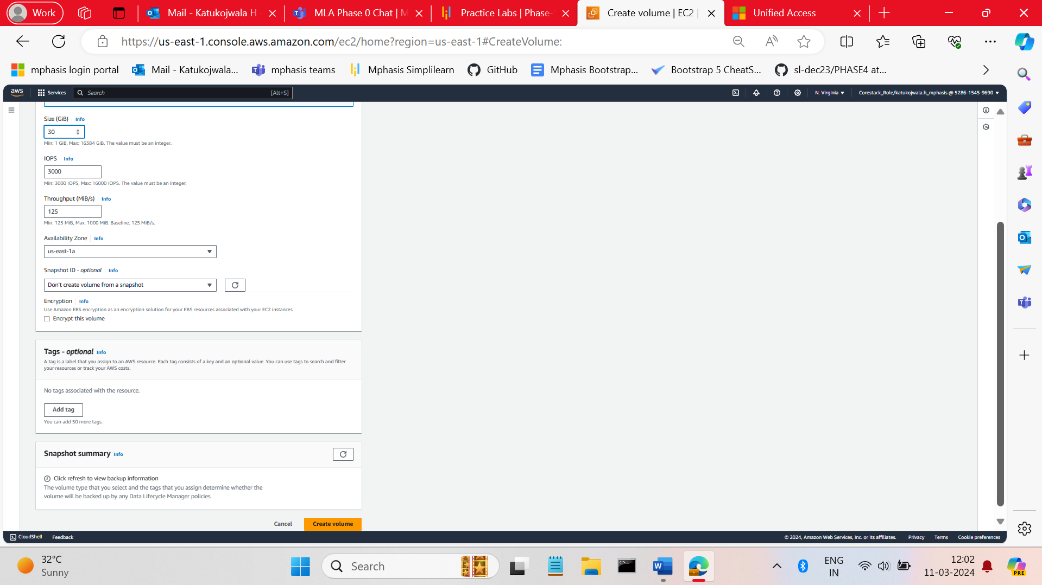
* Change the Volume name has you required. 